Moving On

Studley 3x8

---------------------------------------------------------A ------------------------------------------------------------Z---------------------------------------------------------

Taylor 3x8

-------------------------------------------------------- A ------------------------------------------------------------Z---------------------------------------------------------

Golder 3x8

A--------------------------------------------------------------------------------------------------------------------------------------------------------------------------------Z

Waters 3x8

A--------------------------------------------------------------------------------------------------------------------------------------------------------------------------------Z

**Monday Rehearsal**

1) Students enter. Sit on stage. GO OVER GROUP EXPECTATIONS

2) Set up Chairs/Seating arrangements

3) Practice walking in from Clapping Up

4) Practice walking onto stage/Bowman moment/ shaking hands, etc.

5) Practice Recessional

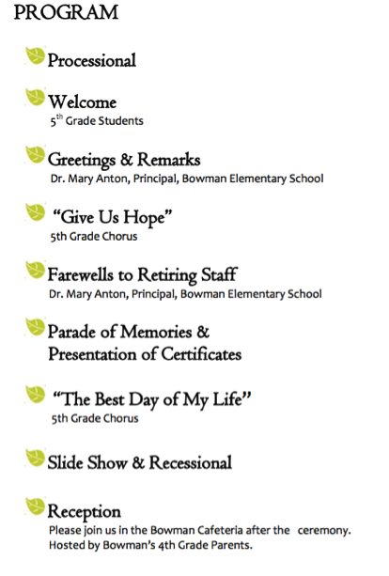

Abby – Intro to all/ Dr Anton

Victoria - Intro Song 1

Intro Song 2

Thank yous/intro to slideshow