Raffle Tickets  1 Ticket - $1  6 Tickets - $5  15 Tickets - $10  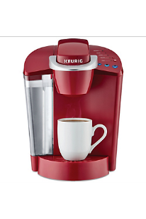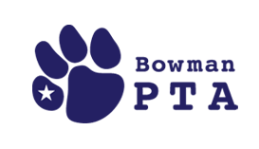  AMAZON ECHO SPOT KEURIG MACHINE BOWMAN SPIRIT GEAR  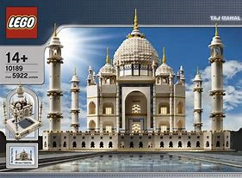  OR A CHANCE TO WIN THE GRAND PRIZE OF THE LEGO TAJ MAHAL AT THE END OF THE NIGHT! | Raffle Tickets  1 Ticket - $1  6 Tickets - $5  15 Tickets - $10  AMAZON ECHO SPOT KEURIG MACHINE BOWMAN SPIRIT GEAR  OR A CHANCE TO WIN THE GRAND PRIZE OF THE LEGO TAJ MAHAL AT THE END OF THE NIGHT!

