The Bowman PTA
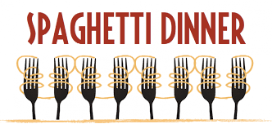
and the 5th grade class cordially invite you to the 10th Annual

Thursday, March 7, 2019
In the Bowman Cafeteria!
Seatings at 5:30, 6:30 and 7:30 pm.

Raffle tickets will also be available for purchase at all three seatings.

Tickets sell out quickly! WE RECOMMEND BUYING ONLINE:
http://bowmanpta.org/spaghetti-dinner-ticket-order/
Tickets on sale until Friday, February 15, 2019

NO TICKETS WILL BE SOLD AT THE DOOR!!

For more information, contact: Sandy Schwartz, Siamak Baharloo, Cindy Arens at spaghettidinner@bowmanpta.org

We recommend buying your tickets online. Alternatively, please return this completed Bowman Spaghetti Dinner Ticket Purchase Form to your classroom teacher with a check made payable to the Bowman PTA. Seating is limited and tickets will be available on a first come-first served basis. Ticket price is $10 per adult and $5 per child. Family cap is $40.00.

___ # Adults ___ # Children for 5:30-6:15 P.M. SEATING Student name:

___ # Adults ___ # Children for 6:30-7:15 P.M. SEATING Teacher name:
Gluten-Free Diet, # of Meals requested
________
___ # Adults ___ # Children for 7:30-8:15 P.M. SEATING Parent email:

Phone:

TOTAL AMOUNT ENCLOSED:

Note: All 5th graders who choose to eat at the dinner must also have a ticket, even if they are working at a different seating.

